2023届初三英语二模试卷
Part 1 Listening (第一部分 听力)
I. Listening comprehension (听力理解) (共25分)
A. Listen and choose the right picture (根据你听到的内容，选出相应的图片) (5分)

(A) (B) (C)
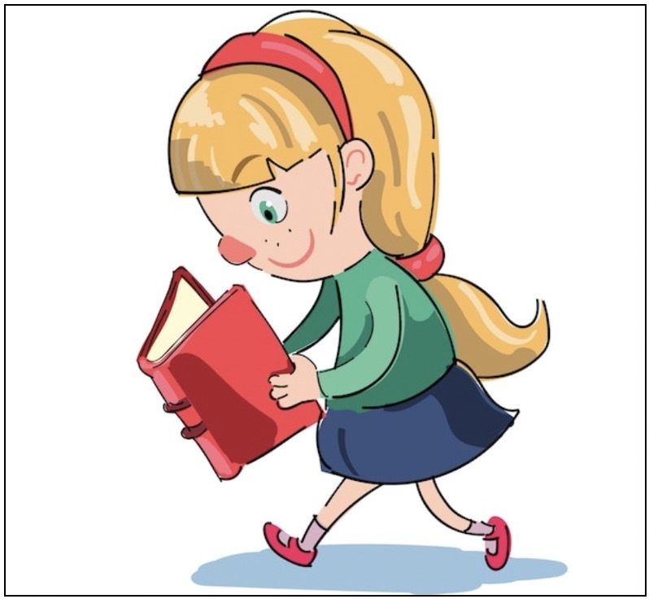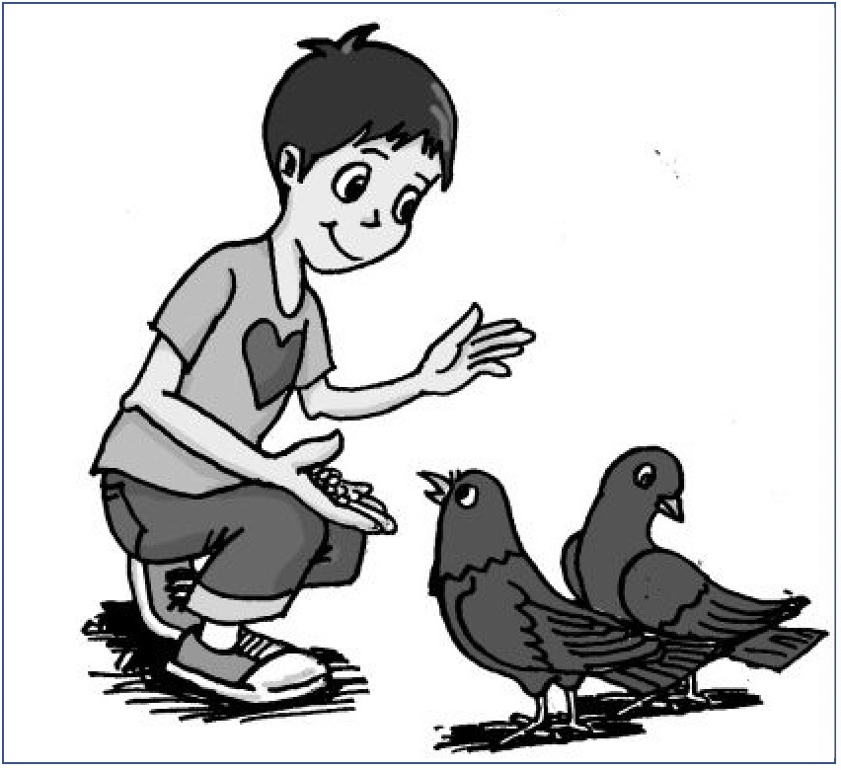
(D) (E) (F)
1.________ 2. ________ 3. ________ 4. ________ 5. ________
B. Listen to the dialogue and choose the best answer to the question you hear (根据你听到的对话和问题，选出最恰当的答案) (5分)
( ) 6. A) A cake. B) Shoes.
C) A scarf. D) Flowers.
( ) 7. A) The manager’s office. B) The front desk.
C) The meeting room. D) The washing room.
( ) 8. A) 15 yuan. B) 30 yuan.
C) 60 yuan. D) 120 yuan.
( ) 9. A) Teacher and student. B) Mother and son.
C) Customer and shop keeper. D) Boss and secretary.
( ) 10. A) How to finish the task.
B) Why to stay in the seaside.
C) What to do in the mountains.
D) Where to spend their weekend.
C. Listen to the passage and tell whether the following statements are true or false (判断下列句子是否符合你听到的短文内容，符合的用“T”表示，不符合的用“F”表示) (5分)
( ) 11. Rose Taylor opened her own company when she was very young.
( ) 12. Rose was once good at painting pictures.
( ) 13. In order to make money, Rose started designing and making clothes.
( ) 14. Though Rose hasn’t finished school, she is successful in the world of fashion.
( ) 15. Rose’s experience shows a hobby can become a career as long as one follows the dream.
D. Listen to the dialogue and complete the following sentences (听对话，完成下列内容。每空格限填一词) (10分)
16. Sara and Bob are going to the theatre ______ ______.
17. They are going to sit in ______ ______.
18. The two tickets cost them ______ ______ because they are students.
19. The play is about a boy who ______ ______ and wants to go to stage school.
20. They will meet at the ________ ________ of the theatre at 6:15.
Part 2 Grammar and Vocabulary
(第二部分 语法和词汇)
II. Choose the best answer (选择最恰当的答案) (共15分)
( ) 21. Do you know Ukraine is ______ European country next to Russia?
A) a B) an C) the D) /
( ) 22. ______ is my duty to clean the white board every Monday.
A) One B) That C) This D) It
( ) 23. John suddenly came up ______ a good idea and helped me through the difficulty.
A) for B) through C) with D) to
( ) 24. —Grandma, ______ do you love most in the world?
—You, of course! My dear!
A) What B) Why C) How D) Who
( ) 25. Which planet is ______ from the earth, Jupiter or Venus?
A) far B) farther C) farthest D) furthest
( ) 26. Peter finished ______ the speech with his teacher’s help.
A) write B) written C) writing D) to write
( ) 27. Some people living on the grassland move from one place to ______ with seasonal. changes.
A) other B) others C) another D) the other
( ) 28. Milk tea in that shop is very popular. Many people wish ______ a try.
A) have B) having C) had D) to have
( ) 29. Jane ______ a DIY card to her Mum on Mother’s Day every year.
A) sends B) is sending C) has sent D) sent
( ) 30. —Whose dictionary is this?
—It ______ be Tom’s. See, his name is on the second page.
A) must B) can C) need D) might
( ) 31. I didn’t answer your phone because at that time I ______ an important meeting.
A) attended B) was attending C) had attended D) would attend
( ) 32. Start right away, ______ you are unlikely to complete the task on schedule.
A) but B) for C) and D) or
( ) 33. How ______ Kitty felt when nobody wanted to talk to her!
A) angrily B) lonely C) sadly D) unfortunately
( ) 34. Jane didn’t understand what the paragraph meant ______ you explained it in detail.
A) that B) if C) until D) because
( ) 35. Your father seldom punishes you for your mistakes, ______?
A) does he B) doesn’t he C) is he D) isn’t he
III. Complete the following passage with the words or phrases in the box. Each can only be used once (将下列单词或词组填入空格。每空格限填一词，每词只能填一次) (共8分)
A) award B) plastic C) strange D) kindness E) automatic

Kids did incredible things in 2022. From fighting against pollution to spreading 36 , kids were leading the way. Let’s look back at two of the amazing kids we met in 2022.
Raphael de Fages de Latour, 11
Each year, around 360 tons of 37 are found in the Seine River. For over two years, Raphael and his dad have spent their weekends fishing litter and garbage out of the river. They have found some 38 items including a radio, an iPhone and a complete motorcycle.
Raphael has more than 20,000 followers on social media. He has used his platform to encourage others to help clean the Seine. In October 2021, he received a(n) 39 from the city for his efforts called The Medal of Paris.
36. ______ 37. ______ 38. ______ 39. ______
A) rarely B) broken C) afford D) reduces E) properly

Logan Ober, 17
Last year, Logan’s computer science teacher let him work on whatever he wanted. So, he decided to fix 40 computers in their classroom. Since then Logan has fixed about $30,000 worth of computers.
Fixing computers 41 e-waste, which is a growing problem across the world. Old computer parts contain materials that can cause harm. If they are not 42 dealt with or reused, they can hurt people and the environment.
After repairing a computer, Logan gives it to a person or an organization. Many students in poor families cannot 43 a new computer. Thanks to Logan, students can get a used computer for free.
40. ______ 41. ______ 42. ______ 43. ______
IV. Complete the sentences with the given words in their proper forms (用括号中所给单词的适当形式完成下列句子。每空格限填一词) (共8分)
44. Joe has a habit of putting away all his ______ after playing with them. (toy)
45. Tom, this is the ______ hamburger you’ve had today. You’ve eaten too much. (five)
46. The twins are similar in appearance, but ______ characters are quite different. (they)
47. It is ______ of you to copy your classmate’s homework. (honest)
48. Zhang Yimou is a famous Chinese film ______ who has won many prizes. (direct)
49. Grandpa was breathing ______ after an hour of climbing without resting. (heavy)
50. The government is making efforts to ______ the problem of air pollution. (solution)
51. Jane was very ______ that a stranger came to her help when she was in trouble. (thank)
V. Complete the following sentences as required (根据所给要求，完成下列句子。每空格限填一词) (共14分)
52. John travelled around the world last year. (改为否定句)
John ________ ________ around the world last year.
53. The Li family have dinner at the restaurant once a week. (对划线部分提问)
______ ______ do the Li family have dinner at the restaurant?
54. Tom often leaves his homework at home. (改为被动语态)
Tom’s homework ______ often ______ at home.
55. Anna had no idea how she could reach to the top of the mountain. (改为简单句)
Anna had no idea ______ ______ reach to the top of the mountain.
56. The amusement park is so big that it is easy for children to get lost. (保持句意基本不变)
The amusement park is so big that it is easy for children to lose ______ ______.
57. “Where will the 2024 Summer Olympics be held?” the teacher asked. (改为间接引语)
The teacher asked ______ the 2024 Summer Olympics ______ be held.
58. take pictures, his family, used to, he, the growth of, to record (连词成句)
_______________________________________________________________.
Part 3 Reading and Writing (第三部分 读写)
VI. Reading comprehension (阅读理解) (共50分)
A. Choose the best answer (根据短文内容，选择最恰当的答案) (12分)

Animal Charity Newsletter (简报)

What can you do to help animals? You may get some information from the following monthly newsletter.
- Pet care advice
The law says we must look after our pets well and give them the things they need to be healthy and happy. Do you do these things for your pet?
1. Environment
Do you give your pet a safe and comfortable place to live?
2. Diet
Do you give your pet the right food and the right amount of food?
3. Company
Do you spend a lot of time with your pet?
4. Health
Do you protect your pet from injuries and pain?
- Volunteers wanted!
Do you want to have fun and help animals in need at the same time? Check out our volunteering activities!
- Help needed at ‘The Horse Sanctuary’ at weekends and evenings
Activities include exercising and feeding horses.
Email us for more information (Animalcharity@gmail.com).
- Dog walkers needed at the Dog Adoption Centre
Help walk the dogs and maybe find a friend for life!
For more information phone 0123 7766.
- Help needed at ‘The Animal Protection Association’
Activities vary from bathing to trimming (剪毛) the small animals.
Call 1325 8743 for more information.
- Events
Fun run!
Raise money for our ‘Animal Habitat Protection’ campaign by joining in our fun run!
Run or cycle 2km, 5km or 7km.
- Where: Hampstead Common
- When: Saturday, 20 March at 15.00
Kids and adults welcome!
- Activities to protect animals’ living places
We’re trying to protect animals’ living places. Please join in our activities! There are lots of things you can do:
- Share information online.
- Tell your friends and family about the activities.
- Make a donation.
- Buy a product from our online shop.
Visit http://worldanimalprotection.org.uk to find out more!

( ) 59. The newsletter comes out every ________.

A) year B) month C) week D) day

( ) 60. The underlined word “Company” most probably means ________.

A) 公司 B) 陪伴 C) 剧团 D) 宾客

( ) 61. If you are a horse lover, you will volunteer to ________ the horses.

A) walk B) bathe C) trim D) feed

( ) 62. The purpose of “Fun run” is to ________.

A) have fun B) find friends C) raise money D) exercise

( ) 63. If you want to know more activities about protecting the animals’ living places, you can________.

A) write an email B) phone 0123 7766

C) visit their website D) visit the charity center

( ) 64. According to the passage, you may do the following to help animals except ________.

A) raising a pet

B) doing volunteer work

C) taking part in the fun run

D) joining in the activities to protect their living places
B. Choose the best words and complete the passage (选择最恰当的单词完成短文) (12分)
This happened to me last summer when I was in South Africa. One day, I fell while getting off a bus and got a small cut on my ankle. I 65 to wash the cut or put a bandage (绷带) on it .
Three days later, I couldn’t put on my shoe because my foot became so enlarged. The pain in my ankle was terrible, and it was moving up my leg. I needed to find a doctor immediately. But in the middle of South Africa, far from a city, a(n) 66 to the hospital looked like this: six hours by car, one day by bicycle, or three days by donkey.
This is when I met Siswana and the leeches (水蛭). Siswana was a traditional doctor from a village 4 kilometers away. She looked at the cut and pushed on it carefully. Then she put her hand on my forehead and nodded her head. Yes, my temperature was 67 . She told me I had a fever and the pus (脓) must get out of the ankle before l could travel to the city the next day to get some antibiotics (抗生素).
She put a wet cloth on my forehead and opened a small metal box. 68 this dirty little box were the leeches which looked like green stones. I put my head back, closed my eyes and tried to think of other things. Then I felt something cool on my skin. Siswana put the leeches gently around the cut on my ankle. Suddenly, I felt them bite, and then I didn’t feel anything. She smiled to help me 69 and tried to make me forget about what was happening on my ankle. An hour later, I found my ankle was bandaged and Siswana was smiling. I thanked her for helping me.
A day later, I travelled 120 kilometers to the next city and got a shot (注射) of antibiotics in a hospital. I’m sure I don’t like shots, but 70 they are more pleasant than leeches!
( ) 65. A) learned B) forgot C) decided D) expected
( ) 66. A) journey B) entrance C) reply D) key
( ) 67. A) freezing B) average C) low D) high
( ) 68. A) Above B) Inside C) Under D) Opposite
( ) 69. A) develop B) change C) relax D) improve
( ) 70. A) at first B) at last C) at least D) at most
C. Read the passage and fill in the blanks with proper words (在短文的空格内填入适当的词，使其内容通顺。每空格限填一词，首字母已给) (14分)
Members of the same family have similarities. However, research shows that there are
d 71 among oldest, middle and youngest children.
The First Born
First-born children are often very responsible and organized. The r 72 is the parents. Parents expect the first-born kid to be an example for the younger children to follow.
First-born children get a lot of attention from their parents. However, they have more rules to follow than younger children. For example, they have an early bedtime. New parents are usually
s 73 with their first child.
The Middle Child
Middle children have to work h 74 to get more attention from their parents. Sometimes they feel left out, so they behave badly to get attention. They are called the “problem children”. Also, they might look outside the family to get attention or to feel special. Middle children are often independent. They are good at solving problems. However, they often go to their friends for advice, not to their parents or siblings.
The Baby
When the t 75 child arrives, parents are usually more confident but less energetic than before. As a result, the youngest child often has more freedom. Bedtimes are later. Parents are also more generous with their money. The baby usually gets what he or she wants.
Last-born children are often more adventurous. They are more l 76 to take risks. They play risky sports such as ice hockey or football.
The youngest children are always funny. When you are the little one, elder brothers or sisters will be nice to you if you make them l 77 .
Every family is different. However, studying birth order may help us understand families.
71. d 72. r 73. s 74. h
75. t 76. l 77. l
D. Answer the questions (根据短文内容回答下列问题) (12分)
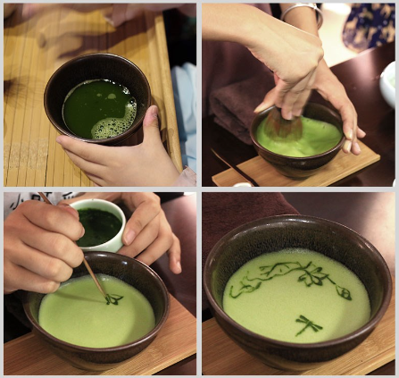
Different from the method of making tea during the Tang Dynasty, in the Song Dynasty the popular way of having tea was Dian cha (点茶).
Han Zheming, a 40-year-old artist from Shanghai, has studied this art and made his skill perfect. Over the past six years, Han Zheming has created nearly 200 ancient paintings on the surface of tea.
In Han’s opinion, the artistic processing of tea can make people have a stronger sense of ritual, so drinking tea is funnier.
Han said, “You can see it as the foam (泡沫) on the top of a cup of coffee, except that it is made of tea but not milk.”
“It is like the way you mix baby milk powder with water,” He said, “About Dian cha, the key is to practice coordination (协调) between the wrist and the arm. It usually needs stirring the mixture between 180 and 200 times before the water and the tea are fully mixed and the foam appears.”
“Then, you make artistic designs in the foam freely with tea powder and spoons.”Han said, “You have to be careful but quick before the foam disappears.”
He experienced many failures before he got going. “Usually, it takes a year of practice to fully grasp the skill. However, the picture on the tea foam will only last about an hour.”
“Dian cha is not only a traditional Chinese skill but also an evanescent (转瞬即逝的) art.” said Han, “I hope to bring the tradition back to modern life and have more people enjoy its charm.”
78. Dian cha was popular in the Song Dynasty, wasn’t it?
__________________________________________________________________________.
79. What has Han Zheming done over the past six years?
__________________________________________________________________________.
80. How many times of stirring are needed before the foam of tea appears?
__________________________________________________________________________.
81. What does an artist use to make designs in the foam?
__________________________________________________________________________.
82. How long does it take an artist to grasp the skill of Dian cha?
__________________________________________________________________________.
83. How do you understand the sentence “Dian cha is not only a traditional Chinese skill but also an evanescent art”?
__________________________________________________________________________.
VII. Writing (作文) (共20分)
84. Write at least 60 words according to the given situation （根据以下情境写一篇不少于60个词的短文，标点符号不占格）
为了解初中生的周末活动安排，玫瑰花园学校（Rose Garden school）采访了150名学生并汇总了部分活动的平均用时（见下图）。从柱状图中，你发现了什么问题？请提出建议并陈述理由。
（注意：1.文中不得出现姓名、校名等个人信息，否则不予评分。
2.照抄阅读语篇不得分。）
