2022学年度第二学期徐汇区学习能力诊断卷

初三年级 英语学科试卷

（考试时间90分钟 满分140分） 2023.4

**Part 1 Listening（第一部分 听力）**

**I. Listening Comprehension (听力理解): (共25分)**

**A. Listen and choose the right picture (根据你听到的内容，选出相应的图片): （5分）**

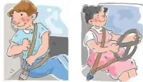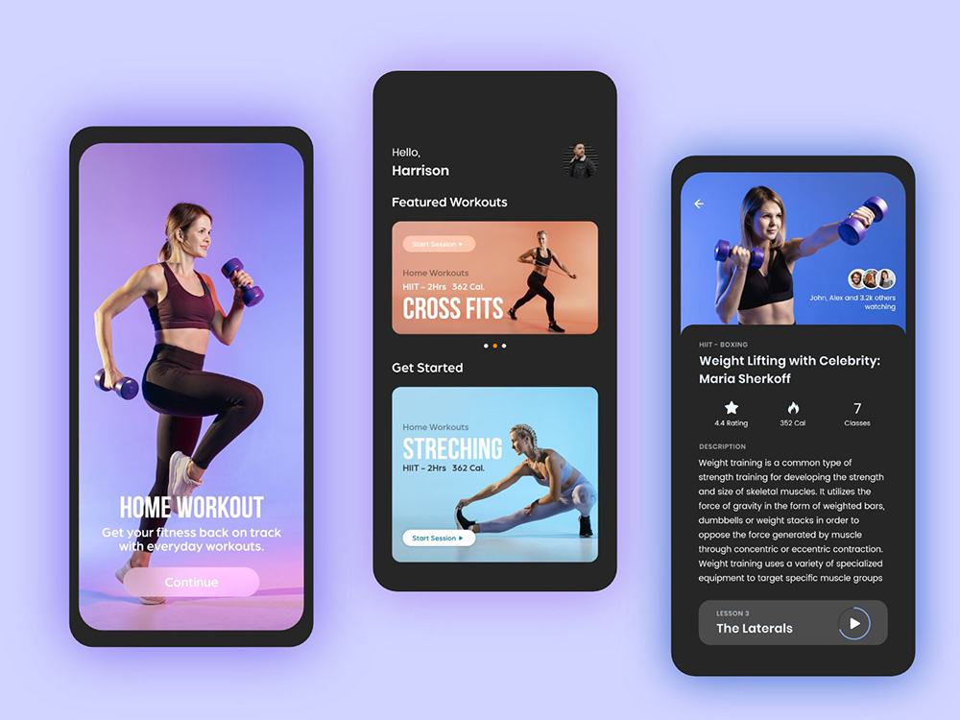 A B C

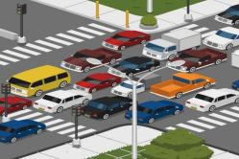

D E F

1. ________ 2. ________ 3. ________ 4. ________ 5. ________

**B.** **Listen to the dialogue and choose the best answer to the question you hear (根据你听到的对话和问题，选出最恰当的答案): （5分）**

（ ）6. A. In China. B. In Singapore. C. In Japan. D. In France.

（ ）7. A. 6 months old. B. 7 months old. C.12 months old. D. 18 months old.

（ ）8. A. An E-dictionary. B. Sports shoes.

C. Tickets for Shanghai Disney. D. Dinner with friends.

（ ）9. A. The reading club. B. The racing club.

C.The language club. D. The cooking club.

（ ）10. A. The change for a new flat. B. The share of housework.

C. The decoration of the bedroom. D. The design of the garden.

**C. Listen to the conversation and tell whether the following statements are true or false (判断下列句子是否符合你听到的内容, 符合的用“T”表示，不符合的用“F”表示): （5分）**

（ ）11. The conversation is about an interview with a journalist in a studio.

（ ）12. David’s first ambition was to be a scientist when he was young.

（ ）13. Because of a special radio program, David became a student journalist.

（ ）14. It was easy for David to get a first job of being a journalist at AFP.

（ ）15. Today’s broadcast is to help the audience learn from David’s experience.

**D. Listen to the passage and complete the following sentences (听短文，完成下列内容，每空**

**格限填一词): (10分)**

1. The speaker is introducing ________ _______ in the world to the audience.
2. Though the Clock Tower was renamed, tourists will call it “Big Ben” ________ _______.
3. The Shanghai TV Tower got the nickname “Pearl of the East” from its _______ _______.
4. The eleven balls of the Oriental Pearl Tower are of _______ _______.
5. Besides offices, the Petronas Towers house a museum, an art gallery and a _______ _______.

**Part 2 Grammar and Vocabulary（第二部分 词汇和语法）**

**II. Choose the best answer（选择最恰当的答案）：（共15分）**

（ ）21. Our monitor is kind and always gives me ________ hand when I have trouble.

A. a B. an C. the D. /

（ ）22. The movie on TV yesterday made me think of an experience of ________ own.

A. I B. me C. my D. mine

（ ）23. Picasso, a famous European artist, had a great influence on art _______ the 20th century.

1. at B. in C. on D. from

（ ）24. The headmaster was very pleased ________ the performance by the talent boy.

1. of B. in C. with D. for

（ ）25. Besides the main character, can you name some ________ little monsters in the cartoon?

1. others B. another C. the other D. other

（ ）26. In Shanghai, PE lessons at school ________ more and more interesting since 2018.

1. become B. became C. have become D. will become

（ ）27. There’s nothing left in the fridge, and we’d better _______ some food in the market.

1. buy B. to buy C. buying D. bought

（ ）28. Counting penguins in Antarctic (南极洲) was one of ________ jobs in the world.

1. strange B. stranger C. strangest D. the strangest

（ ）29. When you wear a smile on your face, you look ________ to customers.

1. warmly B. happily C. correctly D. friendly

（ ）30. ________ kids have smartphones, they may get calls from strangers and get cheated.

1. If B Until C. Though D. Unless

（ ）31. Merle first _______ the world record for swimming 10 kilometers in 2019.

1. sets B. set C. was setting D. has set

（ ）32. The amazing walking tools _______ allow you to walk up to 11 kilometers an hour.

1. need B. can C. must D. should

（ ）33. Follow the instructions carefully, _______ you will operate the machine easily.

1. and B. but C. for D. or

（ ）34. ________ shining the little girl is in her traditional Chinese dress on the stage!

1. What B. What a C. How D. How an

（ ）35. — ________ does your brother go cycling after work?

— Once a week.

1. How far B. How soon C. Hong long D. How often

**III. Complete the following passage with the words or phrases in the box. Each one can only be used once. (选择最恰当的选项填入空格。每空格限填一词，每词只能填一次) (本大题共8题，每题1分，共8分，每题只有一个正确选项):（共8分）**

A. types B. operations C. bored D. popular E. produced

There are many reasons why people like collecting things. First, you can learn a lot about things which are interesting to you. It can also stop you from feeling 36 . It is also possible to meet those who like the same things that you like.

Collecting stamps is one of the most 37 hobbies in the world. King George V of the UK, and also US President Franklin collected stamps.

Some people only collect special 38 of stamps. Edgar (Germany) has more than 11,700 different stamps with pictures of paintings, Celso (Canada) has almost 6,500 stamps about ships, and Daniel (India) nearly 5,000 stamps about birds. The ‘1c Magenta’ is a stamp from British Guiana (英属圭亚那). Someone bought it in 2014 for $9.5 million. It is expensive because it was 39 in 1856 and until now, collectors are pretty sure about the value.

1. ________ 37. ________ 38. ________ 39. ________

A. sense B. realize C. especially D. regularly E. communities

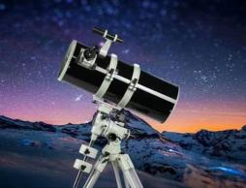Looking up at the stars wasn’t something easy for everyone, 40 in poor areas. For Susan, that changed in her early 20s when she got her first telescope and recognized Saturn (土星). “I saw something I had only read about in a textbook. It made me 41 how small we really are,” says Susan, who is now a scientist. Susan decided to give kids this experience. The project *“The Travelling Telescope*”, brought space education to schools and 42 in Kenya. “So far, more than 300,000 children love the telescope and enjoy the chance to see the moon up close, as well as stars and planets”, says Susan.

In January 2021, pop singer Madonna visited Kenya. Susan watched the pop star’s face light up with the same 43 of wonder as the kids. “It reminds people about the universe that sits just above their heads,” she says.

1. ________ 41. ________ 42. ________ 43. ________

**IV. Complete the sentences with the given words in their proper forms（用括号中所给单词的适当形式完成下列句子，每空格限填一词）：（共8分）**

44. Eating too many sweets is bad for your ________. (tooth)

45. Did you see several ________ sitting on the beach, repairing their nets? (fisherman)

46. Mark Twain’s stories are ________ and full of surprising events of his childhood. (fun)

47. China has seen new ________ in finding ancient things of great value underwater. (develop)

48. It is ________ to stay up late and go to work without having breakfast. (healthy)

49. The volunteers run with the runners to make sure they arrive ________ in the end. (safe)

50. This new book brings together a few stories in a ________ way. (humor)

51. You have to ________ the theatre during the break time when the play is on. (entrance)

**V. Complete the following sentences as required (根据所给要求完成句子。52-57小题每空格限填一词) (本大题共7题，每题2分，共14分)**

52. The boy noticed a few mistakes from a video about wild animals. (改为一般疑问句)

________ the boy ________ a few mistakes from a video about wild animals?

53. AI technology has brought great changes to people’s daily life. (对划线部分提问）

________ ________ AI technology brought to people’s daily life?

1. The detective knows how he can make good use of modern equipment. (改为简单句)

The detective knows ________ ________ make good use of modern equipment.

55. Though there was some difficulty, Mike continued with his work. （保持句意基本不变）

Though there was some difficulty, Mike ________ ________ with his work.

56. “Will you try ChatGPT to do the project?” Mr Li asked the whole class. (改为间接引语)

Mr Li asked the whole class ________ ________ would try ChatGPT to do the project.

1. The local community holds a charity market for books every year. (改为被动语态)

A charity market for books ________ ________ by the local community every year.

1. uncommon, in the library, a musical play, the citizens, found it, to watch (连词成句)

_______________________________________________________________________.

**Part 3 Reading and Writing（第三部分 读写）**

**VI. Reading comprehension （阅读理解）：（共50分）**

**A. Choose the best answer（根据内容，选择最恰当的答案）：（12分）**

Tai chi, part of Chinese culture, is popular around the world. This ancient martial art has been practised by more than 40 million people in more than 150 countries. There must be some reasons for it.

* **Tai chi is good for both body and mind**

This gentle martial art started in China. It requires slow movements with a focus on breathing and on what your body is doing in that moment. You can go at your own speed.

* **It’s easy on the body**

Tai chi is suitable for all ages and levels of fitness. There is little risk of damage to your joints (关节). It’s an exercise that can be easily done, including those in wheelchairs.

* **62**

A 2019 review of studies suggested that Tai chi might reduce the risk of falls in older people. Certainly, the key point is on balance, with sideways and backwards movements helping to have a stronger body. It also improves the awareness of space.

* **It may reduce pain**

A small body of research indicates that doing Tai chi regularly can help repair knee problems and lower back pain.

* **It may improve brain power**

Advantages aren’t just physical. Studies have found that regular Tai chi can improve functioning in brain, especially for older people. Still it’s considered safe and suitable for the elderly.

* **It has the feel-good factor**

A reduction in stress and worry, and an increase in confidence are other advantages of Tai chi for your feelings.

( ) 59. Tai chi is practised by over _______ million people around the world.

1. 20 B. 40 C. 50 D. 150

( ) 60. People move their body _______ when practising Tai chi.

1. violently B. regularly C. slowly D. strongly

( ) 61. All the following people can practise Tai chi **EXCEPT** _________.

1. Mike, a ten-year-old boy, who wants to improve his sense of balance
2. Mr. Li, who has got some pain in his back and decides to do some exercise
3. Ms Black, who was forgetful and needs some training for her brain
4. Dan, who got injured in the leg in a car accident and is in bed these days

( ) 62. The title of the underlined paragraph is “_________”.

1. It can prevent falls B. It has a variety of movements
2. It may open your mind D. It is good for the young

( ) 63. One may feel _______ after practising Tai chi from time to time.

1. stressful B. excited C. confident D. tired

( ) 64. One can find the passage above from the section of “________” in a newspaper.

1. Sports B. News C. Art D. Travel
2. **Choose the words or expressions and complete the passage（选择最恰当的单词或词语完成短文）：（12分）**

**The Find ①:** A rare video game still in its good package.

**Where It Was Found:** In an attic (阁楼).

One day in 2019, Scott was visiting his childhood home to finally clear his stuff out of his mother’s attic. While he was going through the boxes, he came across a shopping bag. Inside it was a video game called *Kid Icaru*. Scott didn’t even remember 65 it. According to the price tag in December 1988, it was most likely a Christmas present that had never been sent. Since it hadn’t been open, this lucky find was a huge deal. According to a gaming expert , *Kid Icaru*s is a highly classic, and there are fewer than ten known unopened copies till now. It is in such a nice condition that it is an uncommon item with a long 66 .

Scott put the video game—which cost $38.45 at that time—up for 67 , and sold it for US$9000. He used the unexpected money to take his family on holiday.

**The Find ②:** A 624-gram gold nugget (金块).

**Where It Was Found:** On a walk.

In 2019, a man took his dog for a walk somewhere outside the city. Joining him were his two daughters, and it’s a good thing they did. “I actually walked right past it,” he later told the reporter. “But my daughter pretty much kicked it as she was 68 . She then asked,‘Dad, is this gold?’” He replied, “I think it might be.” They brought the small nugget to a supermarket nearby to

69 it, and it was up to 624 grams. Experts then made it clear that the nugget was real. “We’d come on some difficult times, so it was the 70 time for better changes,” the dad said. The value is US$25,000.

( ) 65. A. owning B. designing C. borrowing D. selling

( ) 66. A. way B. journey C. history D. list

( ) 67. A. show B. discussion C. fun D. sale

( ) 68. A. sitting B. walking C. dreaming D. thinking

( ) 69. A. decorate B. weigh C. store D. repair

( ) 70. A. first B. last C. right D. hard

1. **Read the passage and fill in the blanks with proper words（在短文的空格内填入适当的词，使其内容通顺。每空格限填一词，首字母已给）：（14分）**

Research suggests that at least 64 percent of people now spend up to four hours daily of free time in front of a screen. Just as TV watching has been linked to higher rates of being fat and other sickness, this is b 71 news for our health. The following are what we can do to get rid of it.

1. **Choose outdoor activities**

When you’re at home, make it a rule that you can’t be online if the sun is shining. I 72 , you have to go for a walk, ride a bike or get some other kind of healthy physical activity for at least an hour. This rule should apply to everyone in your family.

1. **Rearrange the family room furniture**

Design your family room so that the TV is no longer the central point of the room. That means if you want to watch TV, you have to m 73 chairs and tables. Then you can sit and relax yourself.

1. **Limit social media use**

Whether it’s Facebook, Twitter, or WeChat, put limits on the time you spend on social media. Avoid aimless browsing and give your time online a p 74 : research holidays or read the news. Then log off!

1. **Set aside reading time**

Challenge yourself to read at least 30 pages of a great book b 75 you check your mobile phone. Pick the right reading material and you’ll soon find you’ve created a new pastime!

1. **Take part in projects**

Make a list of one-hour e 76 projects. List everything you can possibly think of after dinner at home: organizing cupboards, sharpening knives, sorting through your sewing materials. Then try to do o 77 every day before bedtime.

1. b________ 72. I________ 73. m________ 74. p________
2. b________ 76. e________ 77. o________
3. **Answer the questions（根据短文内容完整回答下列问题）：（12分）**

STAFF PICKS

We enjoyed putting this issue of the magazine together for your reading pleasure. Here are some of our favorites.



**①“Dodie’s Darling Dalmatians”**

Like many of us, I grew up loving the Disney film 101 Dalmatians, but knew little about the book and its relationship with the film. And I even knew less about the story behind it. It was exciting to get a close look at the life of the writer Dodie Smith and her own beloved Dalmatians who provided the idea for his heartwarming story.

Zoe, Managing Editor



**②“My Adventures With A Paint Brush”**

It describes how taking up painting enriched Winston Churchill’s life. The focus of the painting was clearer and he was more aware of colors and details in natural scenery he had ignored before. His story opened my eyes to the wonders of nature, and the different color caused by light and shade that we are too busy to see.

Diane, Senior Editor



**③“Laughter Is The Best Medicine”**

The humor pages show that a good joke can often greatly show the background of its time. It has as much power today to make us smile as it did when it first appeared.

Melanie, Chief Editor



**④“The Great Balloon Escape”**

I love a good Cold War escape story, so naturally I **was drawn to** “The Great Balloon Escape”, which describes in frightening detail how two East German families made a crazy plan to make their own hot-air balloon and fly to freedom.

Diane, Senior Editor

— — — — — — — —— — — —— — — — — — — — — — — — — — — — — — — —

Reader A

I love adventures and I am expecting some exciting moments during the journey.

I have a pet dog and it’s smart and lovely. There are so many interesting stories between us.



Reader B

1. Where do the staff come from, a magazine or a website?

_________________________________________________

1. What did Zoe know little about?

________________________________________________________________

1. Who took up painting as a hobby, according to the picks?

____________________________________________________

1. In Melanie’s view, how can a joke be a good one?

_______________________________________________________________________

1. What does the underlined part “**was drawn to**” mean? Please describe it in another way.

I love a good Cold War escape story, so naturally I ______________ “The Great Balloon Escape”.

1. Please pick two from “Staff Picks” above, one for **Reader A** and one for **Reader B**. Give your reasons.

Reader A may read article ______(123or 4), and Reader B may read article ______(123or 4), because _________________________________________________________________________

________________________________________________________________________________.

**VII. Writing（作文）：（共20分）**

84. **Write at least 60 words according to the given situation (根据以下情境写一篇不少于60个词的短文，标点符号不占格)**

你校正招募志愿者，将在校园开放日欢迎小学五年级学生参观了解校园环境与生活。假如你是Joe，请给校方写封邮件，谈谈作为志愿者，你会介绍校园的哪些亮点或特色。

**（注意：1.信中不得出现姓名、校名等个人信息，否则不予评分。**

**2.照抄阅读语篇不得分。）**

参考短语：School Open Day, Year 5 students，show around

Dear sir,

_____________________________________________________________________________________________________________________________________________________________________________________________________________________________________________________________________________________________________________________________________________________________________________________________________________________

______________________________________________________________________________________________________________________________________________________________________________________________________________________________________________________________________________________________________________________________________________________________________________________________________________________________________________________________________________________________________Yours

Joe